DCPS Science Fair Project Handbook

After you submit the proposal you will need to complete Form 1, 1A, 1B and 3. They can be found at <https://student.societyforscience.org/isef-forms>

A RESEARCH PLAN **MUST** ACCOMPANY Form 1A

**Provide a typed research plan and attach to Student Checklist (1A). Please include your name on each page.**

**The research plan for ALL projects is to include the following:**

**A. Question or Problem being addressed**

**B. Goals/Expected Outcomes/Hypotheses**

**C. Description in detail of method or procedures (The following are important and key items that should be included when formulating ANY AND ALL research plans.)**

**• Procedures: Detail all procedures and experimental design to be used for data collection**

**• Risk and Safety: Identify any potential risks and safety precautions to be taken.**

**• Data Analysis: Describe the procedures you will use to analyze the data/results that answer research questions or hypotheses**

**D. Bibliography: List at least five (5) major references (e.g. science journal articles, books, internet sites) from your literature review. If you plan to use vertebrate animals, one of these references must be an animal care reference.**

**o Choose one style and use it consistently to reference the literature used in the research plan**

**o Guidelines can be found in the Student Handbook**

PROJECT COMPOSITION BOOK

Your Science Project Composition Book is an important piece of evidence that helps you track data and the progress of your project. Keep a record of everything you do in it from the moment you start looking for a scientific problem to the very end. Take notes as you work on your project. Date each time you work on your project. Take time to organize your thoughts so that every entry is as neat as possible. This will show how much effort and time you spent on your project. You may even want to make sketches or take pictures as you go too and paste them in your composition book. This record is the most important part of your project and you will want to display it with your completed project.

PROCEDURES

Clear procedures are important.

-They should be SPECIFIC, nothing should be confusing if anyone tried to replicate your experiment.

-They are listed in a “step 1”, “step 2” format.

-They are thorough enough so that anyone could replicate the experiment and get similar results.

Write the experimental procedure like a step-by-step recipe for your science experiment. A good procedure is so detailed and complete that it lets someone else duplicate your experiment exactly!

Repeating a science experiment is an important step to verify that your results are consistent and not just an accident.

For a typical experiment, you should plan to repeat it at least 10 times.

**The PROCEDURE I will follow to test my variable is:**

**Step 1:__________________________________________________________________________________________________________________**

**Step 2:__________________________________________________________________________________________________________________**

**Step 3:__________________________________________________________________________________________________________________**

**Step 4:__________________________________________________________________________________________________________________**

**Step 5:__________________________________________________________________________________________________________________**

**Step 6:__________________________________________________________________________________________________________________**

DATA TABLES

Data tables should include:

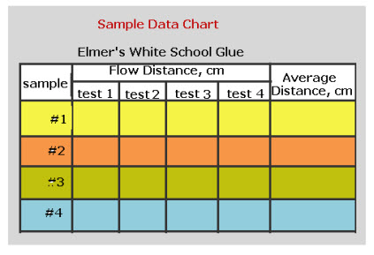-AT LEAST 10 trials are included. REMEMBER, the more trials- the more reliable your experiment will be.

-The units of what is measured (degrees Celsius, cm.)

-What was tested (Independent Variable).

-What was measured (Dependent Variable).

-An average of all trials.

-If applicable, the time when the measurements were taken.

GRAPHS

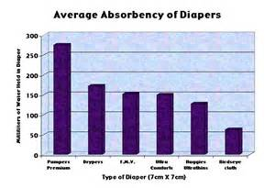Graphs should include:

* Title- IMPORTANT!
* Units on both the X and Y axes.
* A legend off to the side that tells me what each color represents. (if applicable).
* **The independent variable on the x-axis** of your graph and the **dependent variable on the y-axis**.
* The **units of measurement** (volts, inches, grams, etc.).

You can do a line, bar, or even pie graph to represent your data (pick which one shows your data the best.

DATA ANALYSIS

Ever watch a football game? They always have a commentator that gives you information about the game. Now, you can clearly see that this one player just fumbled the ball. But, the commentators explain WHY they fumbled the ball (#42 has had slippery fingers all season…this is his fourth fumble), and what does this fumble means for the rest of the game (they have little chance of intercepting the ball before the end of the fourth quarter. This will be their 10th straight loss of this season).

* The point of this analogy is that YOU need to be the commentator for your project. You did it! You are the expert! Give me a play-by-play.
* What happened? What is affecting your data? What is your table or graph showing you? Why did you get those results?

**Review** your data. Try to look at the results of your experiment with a critical eye. Ask yourself these questions:

* Is it complete, or did you forget something?
* Do you need to collect more data?
* Did you make any mistakes?

CONCLUSION

Your **conclusions** summarize how your results support or contradict your original hypothesis.

* Summarize your science fair project results in a few sentences and use this summary to support your conclusion. Include key facts from your background research to help explain your results as needed.
* State whether your results support or contradict your hypothesis. (Engineering & programming projects should state whether they met their design criteria.)  
  If appropriate, state the relationship between the independent and dependent variable.
* Summarize and evaluate your experimental procedure, making comments about its success and effectiveness.
* Suggest changes in the experimental procedure (or design) and/or possibilities for further study.

It is perfectly fine if your data did not support your hypothesis…the point of science fair it to LEARN something. End by explaining what you found out during your investigation.

**BIBLIOGRAPHY**

List at least five (5) major references (e.g. science journal articles, books, internet sites) from your research plan.

* Your sources should be in MLA format – use easybib.com
* The ISEF website (<https://student.societyforscience.org/intel-isef>) MUST be a source. Where you found your project can be a source and if you used NCES for graphing that can be an additional source.

**BACKBOARD**

Your backboard should be neat and colorful. It should be easy to read from a distance. Please use a full-size backboard. Below is a sample layout and a few pictures of competition quality backboards.

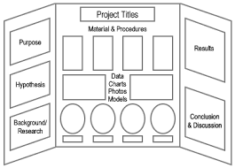 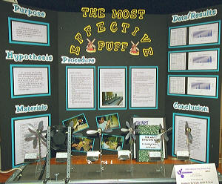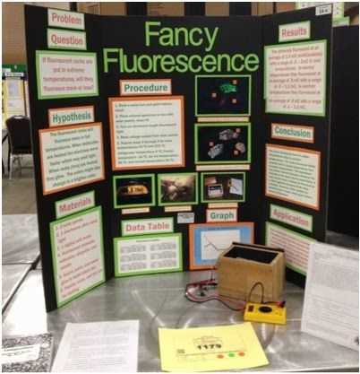 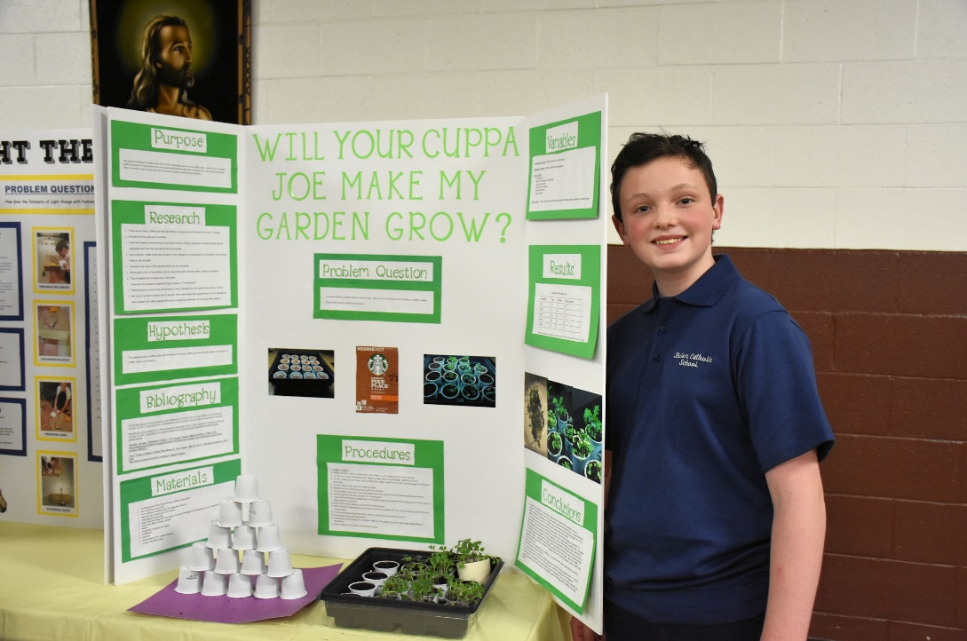

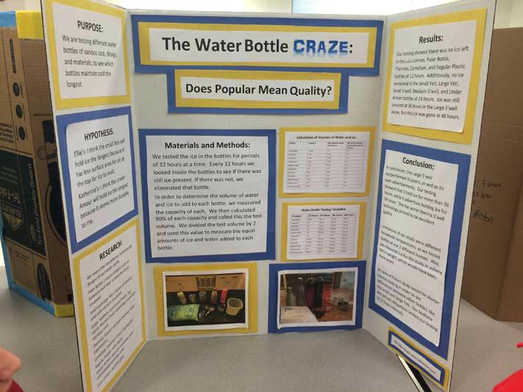

Students competing may also participate in the science fair hosted by North East Florida Regional Science and Engineering Fair (NEFRSEF).

NEFRSEF is very competitive and they require students to complete a research paper. Below is the information for the paper:

Your research should cover:

1. Background information – general information about your problem that might include:
   * Definition and/or explanation of the topic or problem
   * Definition and/or explanation of terms found in the problem
   * Information about topics that relate to the problem
   * Explanation of why it is important to know about this problem
2. Specific Information, including:
   * Results from other experiments similar to yours
   * Information from interviews with experts
   * Studies done by companies or consumer groups that relate to your problem
   * Information necessary to experiment safely

THE PAPER CAN BE TURNED IN WITH THE PROJECT – DECEMBER 6TH